# Accurate Detection and Prediction of Sleep Apnea using 1D CNN-based model

Mahika Gupta1,2, Vedant Swain 1,3 and Himakshi Singh1,4

1 Manipal University Jaipur

2mahika.gupta2002@gmail.com

3vedantswain911@gmail.com

4himakshi10.singh@gmail.com

* Corresponding Author : Ms. Bali Devi, Associate Professor at Manipal University Jaipur

**Abstract.** Sleep apnea is a prevalent sleep disorder that poses a significant health burden on the global population. Accurate detection and prediction of sleep apnea are crucial for effective diagnosis, treatment, and management of this condition. In this research, we propose a 1D CNN model for detecting and predicting sleep apnea using polysomnography (PSG) recordings and respiratory signals. The model achieved high accuracy, outperforming the existing state-of-the-art models. Our findings demonstrate the potential of the 1D CNN model to significantly improve the diagnosis and treatment of sleep apnea, and have significant implications for clinical practice.

**Keywords:** Sleep Apnea, ECG, 1D CNN, Functional APIs.

**1 Introduction**

According to the National Institute of Health (NIH), Sleep Apnea is a sleep disorder that is marked by pauses in breathing of 10 seconds or more during sleep, and causes unrestful sleep. It is a pervasive sleep disorder which may lead to poor sleep quality, daytime somnolence and other adverse health outcomes. Despite its high prevalence, healthcare professionals face significant challenges in accurately detecting sleep apnea.

Recent advances in machine learning techniques, particularly 1D Convolutional Network (CNN) models, have demonstrated remarkable potential in improving the accuracy of sleep apnea detection and prediction. 1D CNNs are capable of learning complex temporal patterns from time-series data, making them well suited for modelling physiological signals associated with Sleep Apnea.

**1.1 Literature Review**

In reference to previously proposed methods, we noticed that ECG signals and other features extracted from them possess the potential to detect Sleep Apnea [1]. For this, various models have been previously implemented. Support Vector Machines provided an accuracy of 90% for detecting Sleep Apnea in patients using ECG data [2]. CNNs, RNNs, and LSTM have also been employed by various researchers for their studies [3]. Heart Rate Variability and other pulse-oximetry signals when inputted in Logistic Regression, Random Forest (RF), Decision Tree and Naive Bayes classfier models [9] have also provided somewhat accurate results in the detection of Sleep Apnea in patients.

In this study, we propose a 1D CNN-based model implemented using functional APIs to accurately detect sleep apnea. We trained the model using a large dataset of polysomnography recordings and respiratory signals and evaluated its performance against existing state-of-the-art models.

**Table 1.** Findings obtained from various research papers

|  |  |  |
| --- | --- | --- |
| PAPER TITLE | DATASET USED | METHODOLOGY/FEATURES |
| Sleep apnea identification using HRV features of ECG signals [2] | MIT-BIH Polysomnographic Database obtained from <https://physionet.org> | Methods used – Artificial Neural Network (ANN), Naïve Bayes Classifier, K-Nearest Neighbour, linear Support Vector Machine (SVM) |
| A systematic review of detecting sleep apnea using deep learning [3] | * HRV and ECG signals for 60 seconds * Nasal airflow (30 seconds) * SpO2 levels for 60 seconds | Implemented models: Deep Vanilla Neural Network (DVNN), Convolutional Neural Network (CNN) and Recurrent Neural Network (RNN). |
| Obstructive sleep apnea detection using convolutional neural network based deep learning framework [5] | Recordings of single lead ECG waveforms from several subjects with diverse OSA conditions, each of 1 min duration. | * Proposed scheme is immune to ambient noise up to a certain extent * The amount of training data does not have any effect on the working of the model |
| A novel algorithm for the automatic detection of sleep apnea from single-lead ECG [1] | 2 datasets comprising 80 ECG recordings and consisting of patients with both Apnea and Hypoapnea. | Least-squares Support Vector Machine classifier using RBF Kernel |

Our study contributes to the expanding literature on the use of deep-learning techniques to accurately detect and predict sleep apnea in patients. Our proposed model has the potential to significantly enhance the accuracy and efficiency of sleep apnea diagnosis and treatment, enabling prompt intervention and improved patient outcomes. The remainder of this paper is structured as follows: Section II provides the methodology utilized to develop and evaluate our proposed model; Section III presents our experimental findings and analysis; and Section IV concludes the paper and outlines future research directions.

**2 Methodology**

**2.1 Dataset and Preprocessing**

The Apnea ECG-dataset[7] used consits of PSG recordings of 25 patients out of which 21 have sleep apnea and 4 do not have sleep apnea, segmented in a window of 11 seconds each. The raw data obtained is cleaned and filtered and converted MATLAB files (.mat) for further processing. This data is then split in the ratio 10:1:1 into training, validation and test sets. All the patient records have been used.

**2.2 Classifiers used : 1D CNN**

CNNs are widely utilized in image classification tasks due to their ability to capture spatial features. A standard CNN architecture comprises five fundamental types of layers: the input layer, convolutional layer, activation functions such as rectified linear units (ReLU), pooling or sub-sampling layer, classification layer (usually a fully connected layer with the softmax function), and batch normalization and dropout layers to enhance the performance of the model [3]. These layers can mitigate overfitting and improve the generalization ability of the network, thereby increasing the accuracy of the CNN model. Functional APIs on the other hand, allow for the creation of complex neural network models by defining multiple inputs and outputs, multiple shared layers, and layer merging operations. Moreover, the functional API allows for the use of different input sizes and shapes, making it possible to incorporate various window sizes, including the 11-second window size used in this study.

Our proposed 1D CNN model employs functional APIs to incorporate three convolutional layers with a stride of 2 for the first layer and 1 for the remaining two layers. We have utilized the maximum pooling technique and the ReLU activation function to improve the accuracy of the model. The functional APIs have enabled us to implement this complex model with ease and flexibility, allowing us to optimize the hyperparameters and architecture of the model efficiently. The detailed architecture of the model is given in Fig. 1.

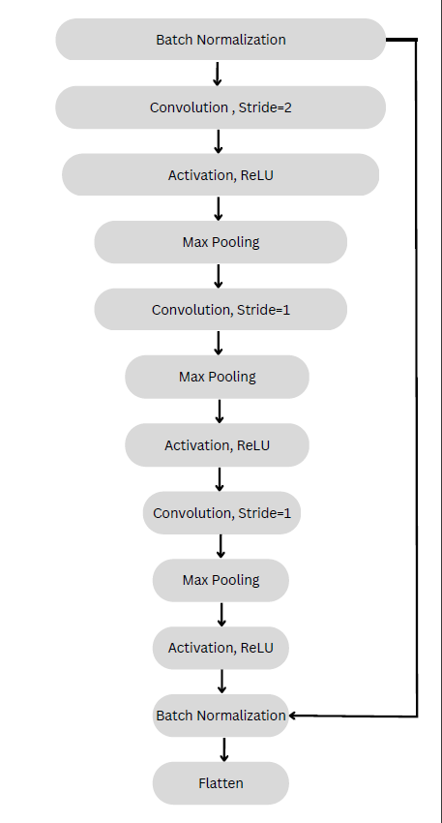  
  
**Fig. 1**. Schematic of the proposed 1D CNN model for the detection of Sleep Apnea

**2.3 Performance Measure Characteristics**

A Confusion Matrix has been used to evaluate the performance and validity of the proposed model. It gives us the value of the true positive (TP), true negative (TN), false positive (FP), and false negative (FN). TP can be defined as the number of correctly identified cases with disorder (apneic), FP as the number of incorrectly identified cases (Type I error [8]) with disorder, TN being the correctly identified healthy cases (non-apneic) and FN is the incorrectly indentified non-apneic cases (Type II error [8]) [3].

According to the NIH(.gov), the accuracy (ACC) of a test is given by its ability to differentiate the patient and healthy cases correctly (eq. 1.). Recall or sensitivity (SEN) is its ability to determine the patient cases correctly (eq. 2.). True positive rate or specificity (SPC) is defined as the ability to determine the healthy cases correctly (eq. 3.). Error Rate (ERR) refers to a measure of the degree of prediction error of a model with respect to the true model (eq 4.). Precision or positive prediction value (PPV) gives the percentage of truly positive outcomes (eq. 5.). Negative prediction value (NPV) is the percentage of only negative outcomes (eq. 6.). False positive rate (FPR) is calculated as the number of positive predictions divided by the total number of negatives (eq. 7.). F1 score (F1) is given by the harmonic mean of precion and recall of the model (eq. 8.). These values can be mathematically defined as:

*ACC = $\frac{TP+TN}{TP+TN+FP+FN}$*  (1)

*SEN = $\frac{TN}{TP+FN}$*  (2)

*SPC = $\frac{TN}{TN+F}$* (3)

*ERR = $\frac{FP+FN}{TP+TN+FP+FN }$* (4)

*PPV = $\frac{TP}{TP+FP}$*  (5)

*NPV = $\frac{TN}{FN+TN}$* (6)

*FPR =* (7)

*F1 =* (8)

**2 Implementation and Performance Analysis**

The proposed model follows the 1D CNN-based classifier that takes the ECG signal as input and outputs a binary classification of whether the patient has apnea. The model was trained for 100 epochs and achieved an accuracy of approximately 99.009%. The confusion matrix of the model is given by Fig. 2.

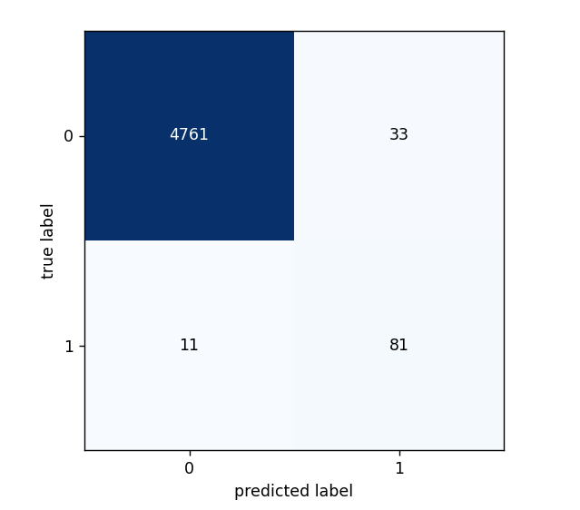  
  
**Fig. 2.** Confusion Matrix for the proposed 1D CNN model

In addition to the above mentioned accuracy, the model exhibits an error rate of 0.64%, positive prediction value of 0.71, sensitivity of 0.88, false positive rate of 0.01, specificity of 0.99, negative prediction value of 0.78, false negative rate of 0.12, and an F1 score of 0.79 is also observed.

The Training and Validation Loss and Accuracy Vs the 100 Epochs curves have been illustrated by Fig. 3. and Fig. 4.

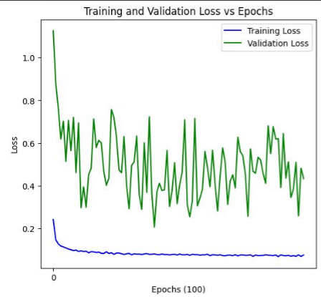

**Fig. 3.** Training Loss and Validation Loss vs Epochs (100) in the training of the model

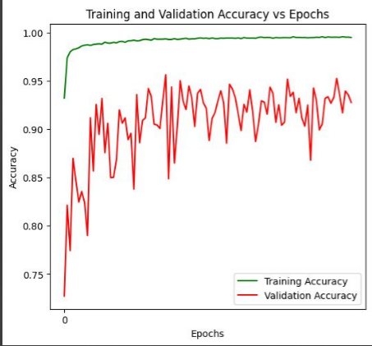

**Fig. 4.** Training Loss and Validation Accuracy vs Epochs (100) in the training of the model

The heatmap and the ROC curve for our model are given by Fig. 5 and Fig. 6.

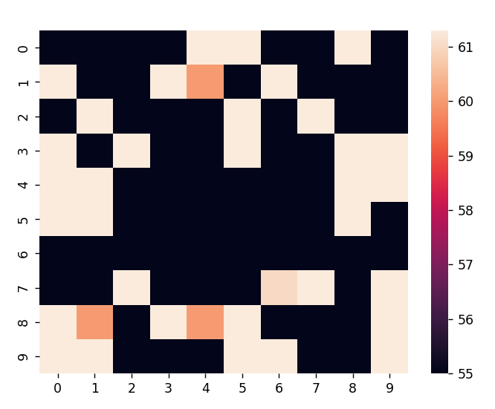  
  
**Fig. 5.** The heatmap for the proposed 1D CNN model

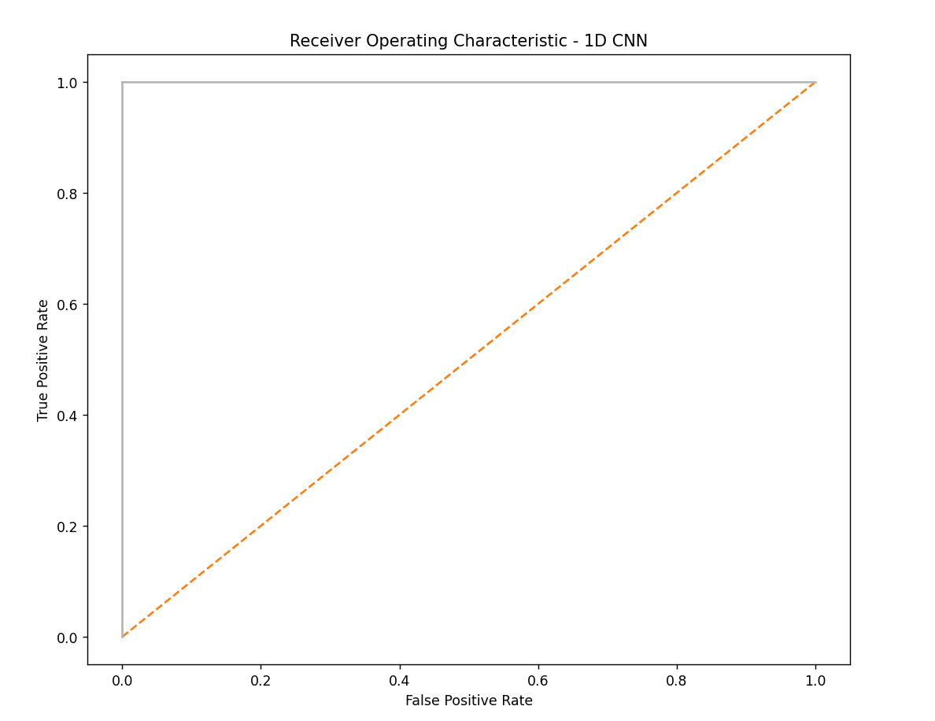  
  
**Fig. 6.** The ROC curve for the proposed 1D CNN model  
  
  
**Table 2.** Comparison between various implemented models and our proposed model

|  |  |  |  |  |  |
| --- | --- | --- | --- | --- | --- |
| INPUT | Paper | Method | ACC (%) | SEN (%) | SPC (%) |
| ECG | [6] | CNN + LSTM | 96.1 | 96.1 | 96.2 |
| [2] | ANN | 73.96 | - | - |
| KNN | 65.80 | - | - |
| N-Bayes | 72.13 | - | - |
| SVM (linear) | 75.87 | - | - |
| [9] | Multiple models | 93 | - |  |
| our paper | 1D CNN | 99.36 | 88 | 99 |

**3 Conclusion**

In conclusion, our study demonstrated the potential of 1D CNN models using functional APIs for the accurate detection and prediction of sleep apnea. By incorporating convolutional layers, max pooling methods, and rectified linear unit (ReLU) activation functions, our proposed model achieved high accuracy and low error rate in classifying sleep apnea events.   
  
The scores given above indicate that the model performs well, with high accuracy and precision. The false-positive rate is very low, which means that the model can correctly identify patients who do not have sleep apnea whereas the false negative rate is slightly higher, which means that the model may miss some patients with sleep apnea. However, the overall performance of the model was very good, and it should be able to accurately identify sleep apnea in most patients. These results have significant implications for clinical practice as accurate and efficient sleep apnea detection and prediction can lead to prompt intervention and improved patient outcomes.   
  
Future research should explore the use of 1D CNN models in combination with other machine learning techniques to further improve the accuracy and efficiency of sleep apnea diagnosis and treatment.

**Acknowledgements**This research paper was supported by Manipal University Jaipur.

**References**

1. C. Varon et al., “A novel algorithm for the automatic detection of sleep apnea from single-lead ECG,” IEEE Transactions on Biomedical Engineering, vol. 62, no. 9, pp. 2269–2278, (2015)
2. B. Sulistyo, N. Surantha, and S. M. Isa, “Sleep apnea identification using HRV features of ECG signals,” International Journal of Electrical and Computer Engineering (IJECE), vol. 8, p. 3940, 10 (2018)
3. S. S. Mostafa, F. Mendonça, A. G. Ravelo-García, and F. Morgado-Dias, “A systematic review of detecting sleep apnea using deep learning,” Sensors, vol. 19, no. 22, (2019)
4. E. Urtnasan et al., “Automated detection of obstructive sleep apnea events from a single-lead electrocardiogram using a convolutional neural network,” J. Med. Syst., vol. 42, no. 6, p. 1–8, (Jun. 2018)
5. D. Dey, S. Chaudhuri, and S. Munshi, “Obstructive sleep apnea detection using convolutional neural network based deep learning framework,” Biomedical Engineering Letters, vol. 8, pp. 95–100, (Dec 2017)
6. L. Chen, X. Zhang, and C. Song, “An automatic screening approach for obstructive sleep apnea diagnosis based on single-lead electrocardiogram,” IEEE Transactions on Automation Science and Engineering, vol. 12, no. 1, pp. 106–115, (2015)
7. “St. Vincents University Hospital/ University College Dublin sleep apnea database,” (2011), [Online], <http://physionet.org/physiobank/database/ucddb/>
8. E. Olivette, S. Greiner, P. Avesani, “Statistical independence for the evaluation of classifier based diagnosis,” Brain Inf. 2, 13–19, (2015).
9. N. L. Molin, C. Molin, R. J. Dalpatadu, A. K. Singh, “Prediction of Obstructive Sleep Apnea using Fast Fourier Transform of overnight breath recordings,” Machine Learning with Applications, (2021)